Professional Readiness for

Innovation, Employability and Enterpreneurship

**SMART HOME**

**Submitted By:**

**M.Anusuya**

**Reg No: 961819106301**

**Batch No:12**

**Car parking and room temperature sensor**

**Program:**

int t = 2;

int e = 3;

void setup()

{

Serial.begin(9600);

pinMode(t,OUTPUT);

pinMode(e,INPUT);

pinMode(13,OUTPUT);

pinMode(8,OUTPUT);

}

void loop()

{

digitalWrite(t,LOW);

digitalWrite(t,HIGH);

digitalWrite(13,LOW);

delayMicroseconds(10);

digitalWrite(t,LOW);

float dur = pulseIn(e,HIGH);

Serial.print(" is the distance");

float dis = (dur*0.0343)/2;

Serial.print("cm);

Serial.print(dis);

digitalWrite(13,LOW);

if (dis<50)

digitalWrite(13,HIGH);

else

digitalWrite(13,LOW);

if(dis>50)

digitalWrite(13,LOW);

Serial.println("the object is away from your range ");

double a = analogRead(A1);

double t=(((a/1024)*5)-0.5)*100;

Serial.println("TEMP VALUE: ");

Serial.println(t);

if(t>50)

digitalWrite(8,HIGH);

else

digitalWrite(8,LOW);

if(t>50)

Serial.println("The room temperature is too high");

else

Serial.println("Normal temparature");

delay(1000);

}

**FIGURE:**

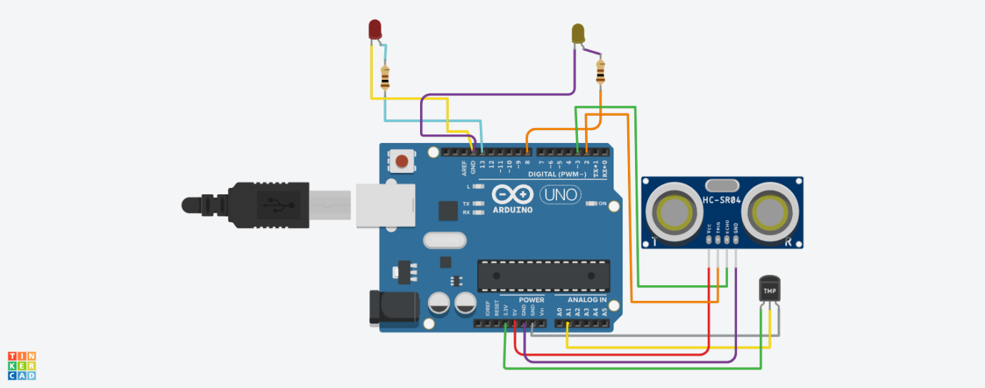

**WORKING:**

**Taking an example of car parking at smart home**:

Whenever any object is within the range of ultrasonic sensor the microcontroller detects the distance and indicate it my an indicator (Red LED).If the object is away means the indicator will off.

**Taking an example of a smart home temperature:**

Whenever the room temperature is high then it is indicated by an indicator and a notify that the room temperature is too high. If the room temperature is normal then it sends an message as normal temperature.

**Tinkercad link:**

<https://www.tinkercad.com/things/cWWVVpsmqFg-neat-amur-rottis>